*Approval of Stabilization of Similar Images*

Anil Kumar Gupta  
ganilkumar226@gmail.com

*Abstract*—This is the project based on Hierarchical temporal memory (HTM). HTM is a new machine learning method. It is biologically inspired cognitive method based on the principle of how human brain works. The purpose of my project was to perform Test for checking stability of similar kind of JPG/PNG Images. Therefore, the key idea of this project to tests and research how spatial pooler generates same output for slightly different changes of input images (data). Spatial pooler used to upload the Images. In addition, LearningAPI ImageBinarizer of FH Frankfurt was used to Binarize the uploaded data. Furthermore, NeoCortexAPI(1.0.5 beta) Nugget Package was provided to create interface between My task has to show how selected active columns returned in active Array after invoking of method compute and position X,Y is changed to original images to find out , how active columns i.e. active Array is varying. Additionally, Error percentage is added to reflect the errors in Binarized images. In addition, hamming distance has been calculated. Unit Test is performed to verify the Characteristics of the algorithm in this project.

# Introduction

Approval of stabilization of similar images is a part of Hierarchical temporal memory project in software Engineering. Spatial pooler is an integral part of the HTM algorithm that is useful for a generalized representation of the inputs. Moreover, The Hierarchical Temporal Memory is a cognitive learning algorithm, which was designed based on various principles of neurosciences and human brain responsible for learning, classification and making prediction. This project introduces the stability of images in which images is uploaded using provided spatial pooler and that input data is trained and ImageBinarizerAPI used to get the Binarized form of input images. Additionally, some noise Percentage error has been added by flipping number of 1 and 0 with changing dimension of input images. In order to obtain clear output of image stability for this research. Same images is taken by shifting right to left and so on. And such task has been performed for more than 10 images and output is shown, 1.Active columns of Trained images 2. Hamming Distance between Trained Image and Prediction of it, Image with 90 degree rotate. 3. Active column of prediction of Trained Image and prediction of same image with 90° rotation 4. Active Columns of Prediction of Trained Images with Noise of 1%. 5. Active Columns of Prediction of Trained Image with Noise of 5% 6. Hamming Distance between Trained Image and Prediction of same Image with 5% Noise.

# Methods

During the test, the input Images are fixed with variables image Width and height accordingly output width and Height integer. Furthermore, similar imageare uploaded withspatial pooler Also Training and prediction is done with NeoCortexAPI library. And overview of this project is, the project has mainly two parts the first one is Image Binarizer and image stabilization. Firstly, data image uploaded into the program, Binarized and Hamming distance calculated according to changes and error percentage added in loaded image data.

## Hierarchical Temporal Memory

HTM replicates the structural and algorithmic properties of the neocortex. Basically, a sequence memory algorithm that aims at emulating the foundation principles of the neocortex. It can be regarded as a memory system, which is not programmed but trained through exposing it to data flow. The process of training is similar to the way humans learn .HTM has no knowledge of data stream causes it examines, but through a learning process, it explores the causes and captures them in its structure. The training is considered completed when all the latent causes the data are captured and stable.

## Spatial pooler and Neocortex

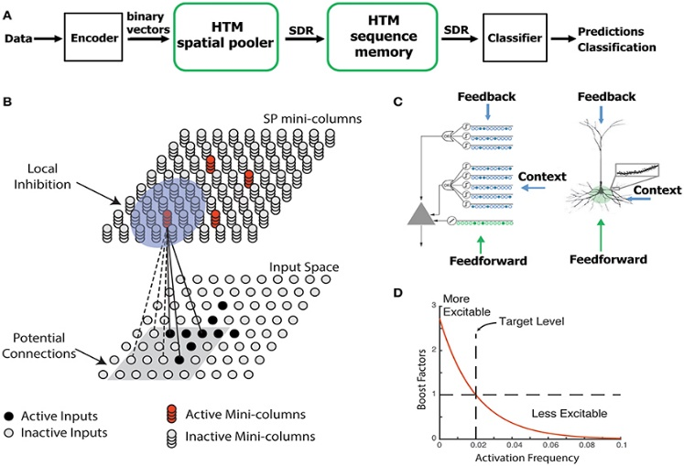

1. *Spatial pooler characteristic*.

The first property of spatial pooler is to form fixed-sparsity representation of the input. To contribute to further neural computation, the output of the spatial pooler have to be recognized by downstream neurons. A second property is that the system should utilize all available resources to learn optimal representation of the input. Neocortex overall 1000cm 2.2 mm thick containing 30 billion cells and 100 trillion synapses. Nearly identical architecture and differentiated by connectivity, common algorithms. Hierarchy is convergence and Temporal slowness.

## Spatial Pooling

Above Spatial, pooler characteristic concludes a more sophisticated and biologically plausible neural model than is typically employed. In artiﬁcial neural network research. This model is structured as a hierarchy of regions, where each region consists of a set of columns and each column consists of a set of neurons and their associated dendrites and synapses. An HTM column currently only implements the functionality of the layer three and four neurons found in the neocortex. According to HTM theory, these neurons control which columns in a region are currently active, and which are currently predicting they will be active. The ﬁrst function is determined by a procedure known as spatial pooling and the second by a procedure known as temporal pooling. The basic task of the spatial pooler is to form a sparse distributed representation of the input. This is required by the temporal pooler in order to learn and predict t the sequential order of particular input streams. However, to be biologically plausible as well as practically useful, the spatial pooler must also be able to eﬃciently form a relatively stable representation of a continuous stream of input.

## Image Binarizer

This NeocortexAPI ImageBinarizer library is used to Binarize the input images. Moreover, this tool only can give the output string to display to console window or as a text file into 0 and 1. A black and white picture can be converted into 0 and 1 (0 for black and 1 for white). It reads pixels and converts accordingly. Banalization is the action of binaries (make binary with 2 elements) data. Moreover, if picture is not in black white, it has converted to grayscale.

## Implementation

Here, the matter is straightforward. If the images dimension and threshold is greater and high, it takes long time to process to convert into Binarize image and calculate hamming distance. The following code shows how input image data is loaded in initialized pooler and trained by invoking of compute() method. Several Input dimension vectors Image height and Image width were chosen to show that same input vector resulted to same output active columns and also that different input dimension vector resulted to different active column and Various noise added to show the Noise robustness stability of Spatial Pooler using hamming distance to calculate variation in output.

### Local and Global Inhibition:

Local and Global Inhibition is used to show the comparison and stability difference between trained and Untrained data. In addition, result are taken setting flowing parameters both inhibitions.

Parameters.Set(KEY.GLOBAL_INHIBITION, false);

bool withTraining = false;

# Results

Some similar image are taken as input data and checked their stability with different forms including Shift, rotation, Different image and with adding noise errors as well. Original Image are binarized and trained it in Spatial pooler with adding different percentage of noise and placed changing coordinate to check the stability of similar images.

I checked stability of images for various image data by 0%, 1%, 5%, 10%, 20%, 30%, 40%, 50%, 60%, 70%, 80%, 90%, 100% with each tests. Among them few tests are as following and for remaining images and output:

**Link to Repository**:

**TestProject:** MyProject\ImageStabilizationHtm\ImageStabilizationHtmTests\bin\Debug\netcoreapp2.1\Output

**Diagrams:** MyProject\ImageStabilizationHtm\ImageStabilizationHtmTests\bin\Debug\netcoreapp2.1\Images

## Original Image

This is the original Image, which is converted to Binarized image and then trained in the Spatial Pooler.

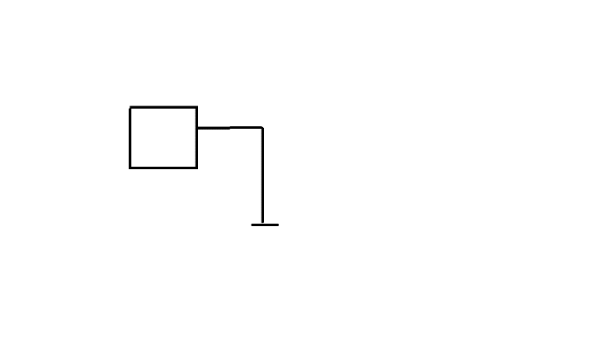

1. *Lamp.PNG Original Image*

This is the Binarized image of the original image (Fig 1 Lamp.PNG). After Binarization, it is trained in Spatial Pooler.

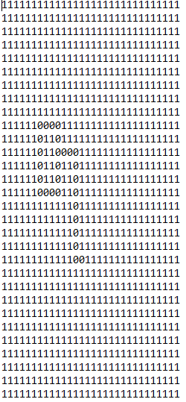

1. *Binarized Image of fig.2 Lamp.PNG*

### Global Untrained Spatial Pooler:

This is the Graph showing Active columns produced by Global Untrained image of Fig.2 Lamp.PNG. Total Number of Active columns is 210. Where vertical columns represents values (1 if the index of output column is Active and 0 if the index of output column is inactive). Similarly, the Horizontal axis shows the index of output column.

1. *Active Columns produced by Global Untrained Spatial Pooler for original Image fig.2 Lamp.PNG*

### Global Trained Spatial Pooler:

The Graph shows the Active Columns of Trained Spatial Pooler Image Fig1 Lamp.PNG. This Graph represents Active columns produced by Global Trained image of Fig.2 Lamp.PNG. And the total number of Active columns is 72.where vertical columns represents values (1 if the index of output column is Active and 0 if the index of output column is inactive). Similarly, the Horizontal axis shows the index of output column.

1. *Active Columns produced by Global Trained Spatial Pooler for original Image fig.2 Lamp.PNG*

### Local Untrained Spatial Pooler:

The Graph concludes the Atcitve Columns of Local untrained Image. This Graph represents Active columns produced by trained image of Fig.2 Lamp.PNG, where vertical columns represents values (1 if the index of output column is Active and 0 if the index of output column is inactive). Similarly, the Horizontal axis shows the index of output column. In addition, the total number of Active columns is 214 for trained image Fig.2 Lamp.PNG in local untrained spatial pooler.

1. *Active Columns produced by Local Untrained Spatial Pooler for original Image fig.2 Lamp.PNG*

### Local Trained Spatial Pooler:

The below given Graph shows the Active Columns of Local Trained Image. This Graph represents Active columns produced by Local Trained image of Fig.2 Lamp.PNG, where vertical columns represents values (1 if the index of output column is Active and 0 if the index of output column is inactive). Similarly, the Horizontal axis shows the index of output column. . And the total number of Active columns is 214 for trained image Fig.2 Lamp.PNG in local trained spatial pooler.

1. *Active Columns produced by Local Trained Spatial Pooler for original Image fig.2 Lamp.PNG*

## Shifted Image

Original Image Shifted towards x+k.

This is the original Shifted image, which is converted to Binarize Image and then trained in the Spatial Pooler.

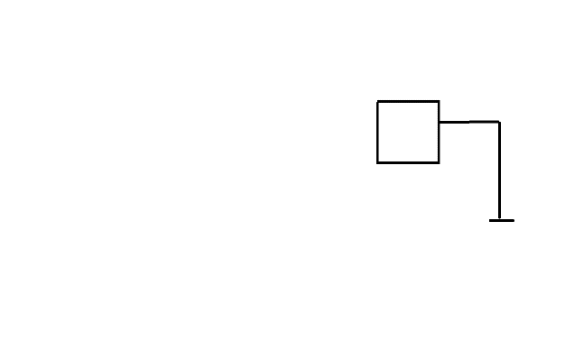

1. *LampShifted.PNG Shifted form of Original Image.*

This is the Binarized image of shifted image of original trained image. After Binarization, it is used for prediction.

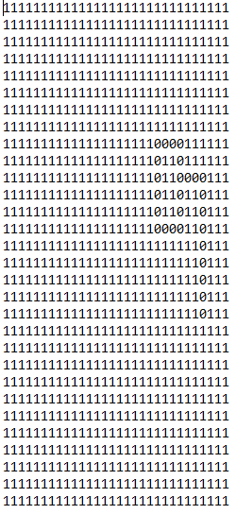

1. *Binarized image of Fig.18 LampShifted.PNG.*

Active column of prediction of Trained Image and Untrained.

### Global Untrained:

This is the graph, showing the Active columns of Global untrained Image, which is the Shifted form of original Image *Fig.2 .*The Blue colored lines are showing the Active columns of *Fig.8.*The total number of Active columns of prediction of untrained image as shown in figure below.

1. *Active Columns produced by Global Untrained spatial Pooler for original Image fig.2 Lamp.PNG.*

The Graph showing change in Active Columns between Global Untrained Original Image (Fig.4) and Shifted image (Fig.10).

1. *Active Columns, which are not common between Original Image and Shifted image produced by Global Untrained Spatial Pooler.*

Above Graph shows the difference between the active columns of Original Image and Shifted image produced by Global Untrained Spatial Pooler. The indexes at which these changes occur are shown as value 1. The total number of these indexes is 39. Also, the hamming distance in this case is 39, which denotes these indexes. Therefore, by the help of this graph we can compare the stability of image. If the density of these lines are less, then the image is stable as there are less changes or less hamming distance and if the density of these lines are more, then the image is less stable as there are more Changes or more hamming distance. Thus, by comparing the density of this graph, we can tell the stability.

Output Overlap table of Global Untrained with respect to different shifts in Original Image, i.e., without shift, shift by 25%, shift by 50%, shift by 75% and shift by 100%.

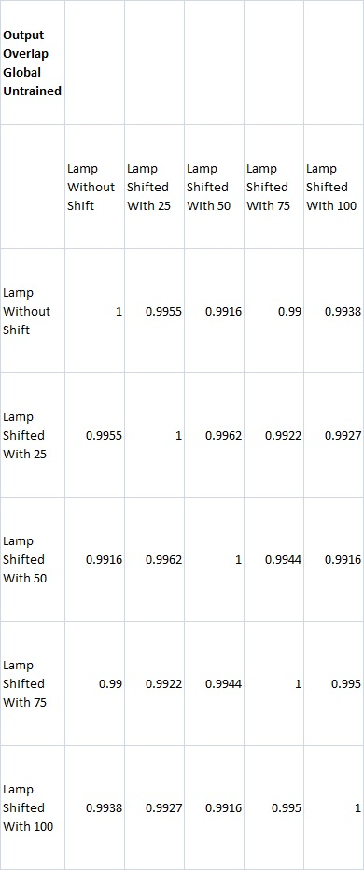

1. *Table showing Output Overlaps of Global Untrained with different shifts compared to each other.*

From the above table, we can see that the output overlaps of Global Untrained Spatial Pooler are compared for different shifts. These output overlaps are not only found by taking only one shift as a base and other shifts as comparison but also taking all shifts as base one by one and compared all other shifts to get this result.

### Global Trained:

This is the graph, showing the Active columns of Global trained Image, which is the Shifted form of original Image *Fig.2 .*The Blue colored lines are showing the Active columns of *Fig.8.*The total number of Active columns of prediction of trained image as shown in figure below.

1. *Active column produced by Global trained spatial pooler for fig.8 which is shifted form of original image.*

Output Overlap table of Global Trained with respect to different shifts in Original Image, i.e., without shift, shift by 25%, shift by 50%, shift by 75% and shift by 100%.

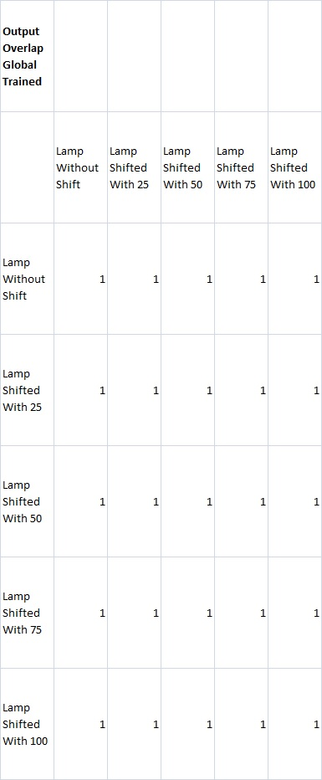

1. *Table showing Output Overlaps of Global Trained with different shifts compared to each other.*

From the above table, we can see that the output overlaps of Global Trained Spatial Pooler are compared for different shifts. These output overlaps are not only found by taking only one shift as a base and other shifts as comparison but also taking all shifts as base one by one and compared all other shifts to get this result.

### Local Untrained:

This is the graph, showing the Active columns of Local untrained Image, which is the Shifted form of original Image *Fig.2 .*The Blue colored lines are showing the Active columns of *Fig.8.*The total number of Active columns of prediction of untrained image as shown in figure below.

1. *Active column produced by Local Untrained spatial pooler for fig.8, which is shifted form of original image.*

The Graph showing change in Active Columns between Local Untrained Original Image (Fig.6) and Shifted image (Fig.15).

1. *Active Active Columns, which are not common between Original Image and Rotated image produced by Local Untrained Spatial Pooler.*

The Graph shows the difference between the active columns of Original Image and Shifted image produced by Local Untrained Spatial Pooler. The indexes at which these changes occur are shown as value 1. The total number of these indexes is 122. Also, the hamming distance in this case is 122, which denotes these indexes. Therefore, by the help of this graph we can compare the stability of image. If the density of these lines are less, then the image is stable as there are less changes or less hamming distance and if the density of these lines are more, then the image is less stable as there are more Changes or more hamming distance. Thus, by comparing the density of this graph, we can tell the stability. We can see in Fig.11 which is trained image has hamming distance is 39 but in this change graph has 122 changed hamming distance which is less stable than trained image.

Output Overlap table of Local Untrained with respect to different shifts in Original Image, i.e., without shift, shift by 25%, shift by 50%, shift by 75% and shift by 100%.

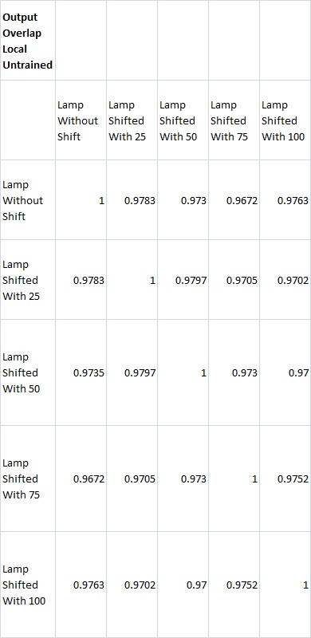

1. *Table showing Output Overlaps of Local Untrained with different shifts compared to each other.*

From the above table, we can see that the output overlaps of Local Untrained Spatial Pooler are compared for different shifts. These output overlaps are not only found by taking only one shift as a base and other shifts as comparison but also taking all shifts as base one by one and compared all other shifts to get this result.

### Local Trained:

This is the graph, showing the Active columns of Local trained Image, which is the Shifted form of original Image *Fig.2 .*The Blue colored lines, are showing the Active columns of *Fig.8.*The total number of Active columns of prediction of trained image as shown in figure below.

1. *Active column produced by Local Trained spatial pooler for fig.8, which is, shifted form of original image.*

Graph showing change of Active Columns between Local Trained Original Image (Fig.18) and Shifted image (Fig.7).

1. *Active Columns, which are not common between Original Image and Shifted image produced by Local Trained Spatial Pooler.*

Above Graph shows the difference between the active columns of Original Image and Shifted image produced by Local Trained Spatial Pooler. The indexes at which these changes occur are shown as value 1. The total number of these indexes is 39. Also, the hamming distance in this case is 39, which denotes these indexes. Therefore, by the help of this graph we can compare the stability of image. If the density of these lines are less, then the image is stable as there are less changes or less hamming distance and if the density of these lines are more, then the image is less stable as there are more changes or more hamming distance. Thus, by comparing the density of this graph, we can tell the stability of Untrained active columns fig.16 which has hamming distance 122 which is high than trained image which has 39 hamming distance showing more stable than untrained Image.

Output Overlap table of Local Trained with respect to different shifts in Original Image, i.e., without shift, shift by 25%, shift by 50%, shift by 75% and shift by 100%.

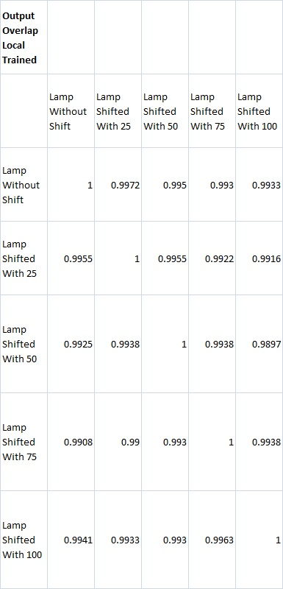

1. *Table showing Output Overlaps of Local Trained with different shifts compared to each other.*

From the above table, we can see that the output overlaps of Local Trained Spatial Pooler are compared for different shifts. These output overlaps are not only found by taking only one shift as a base and other shifts as comparison but also taking all shifts as base one by one and compared all other shifts to get this result.

From the tables of Output Overlaps for all four cases, we can conclude that the images under Global Trained Spatial Pooler are most stable for different shifts and the images under Local Untrained Spatial Pooler are least stable for different shifts.

## Rotated Image

Original Image rotated by 90°.

This is the rotated image of original trained image and this is used for prediction after Binarization.

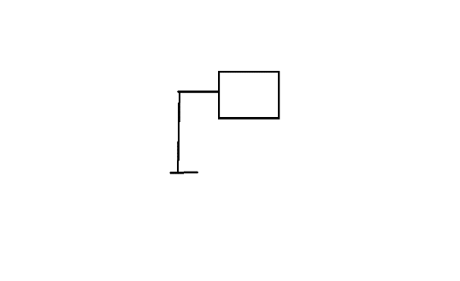

1. *LampRotate.PNG*

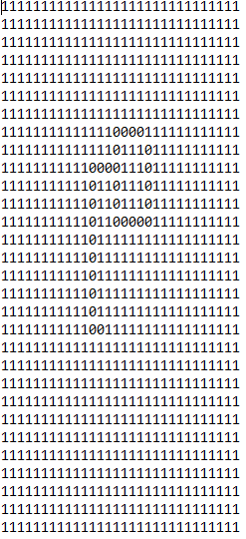

1. *Binarized image of fig.21 Rotated image of original image fig.2 Lamp.PNG.*

### Global Untrained:

This is the graph, concluding the Active columns of Global untrained Image, which is the rotated form of original Image *Fig.2 .*The Blue colored lines are showing the Active columns of *Fig.21.*The total number of Active columns of prediction of untrained image rotation.

1. *Active Columns produced by Global Untrained spatial Pooler for original Image fig.2 Lamp.PNG.*

Graph showing change in Active Columns between Globally Untrained Original Image (*Fig.4*) and Rotated image (*Fig.23*).

1. *Active Columns, which are not common between Original Image and Rotated image produced by Global Untrained Spatial Pooler.*

Above Graph shows the difference between the active columns of Original Image and Rotated image produced by Global Untrained Spatial Pooler. The indexes at which these changes occur are shown as value 1. The total number of these indexes is 24. Also, the hamming distance in this case is 24, which denotes these indexes. Therefore, by the help of this graph we can compare the stability of image. If the density of these lines are less, then the image is stable as there are less changes or less hamming distance and if the density of these lines are more, then the image is less stable as there are more changes or more hamming distance. Thus, by comparing the density of this graph, we can tell the stability.

### Global Trained:

This is the graph, showing the Active columns of Global trained Image, which is the rotated form of original Image *Fig.2 .*The Blue colored lines are showing the Active columns of *Fig.21.*The total number of Active columns of prediction of trained image rotation.

1. *Active Columns produced by Global trained spatial Pooler for original Image fig.2 Lamp.PNG.*

### Local Untrained:

This is the graph, demonstrating the Active columns of Local untrained Image, which is the rotated form of original Image *Fig.2 .*The Blue colored lines are showing the Active columns of *Fig.21.*The total number of Active columns of prediction of untrained image rotation.

1. *Active Columns produced by Local Untrained spatial Pooler for original Image fig.2 Lamp.PNG.*

Graph showing change in Active Columns between Local Untrained Original Image (*Fig.6*) and Rotated image (*Fig.26*).

1. *Active Columns that are not common between Original Image and Rotated image produced by Local Untrained Spatial Pooler.*

The Graph shows the difference between the active columns of Original Image and Rotated image produced by Local Untrained Spatial Pooler. The indexes at which these changes occur are shown as value 1. The total number of these indexes is 76. Also, the hamming distance in this case is 76, which denotes these indexes. Therefore, by the help of this graph we can compare the stability of image. If the density of these lines are less, then the image is stable as there are less changes or less hamming distance and if the density of these lines are more, then the image is less stable as there are more changes or more hamming distance. Thus, by comparing the density of this graph, we can tell the stability.

### Local Trained:

This is the graph, representing the Active columns of local trained Image, which is the rotated form of original Image *Fig.2 .*The Blue colored lines are showing the Active columns of *Fig.21.*The total number of Active columns of prediction of trained image rotation.

1. *Active column produced by local trained spatial pooler.*

Graph showing change in Active Columns between Local Trained Original Image (*Fig.6*) and Rotated image (*Fig.28*).

1. *Active Columns, which are not common between Original Image and Rotated image produced by Local Trained Spatial Pooler.*

Above Graph shows the difference between the active columns of Original Image and Rotated image produced by Local Trained Spatial Pooler. The indexes at which these changes occur are shown as value 1. The total number of these indexes is 24. Also, the hamming distance in this case is 24, which denotes these indexes. Therefore, by the help of this graph we can compare the stability of image. If the density of these lines are less, then the image is stable as there are less changes or less hamming distance and if the density of these lines are more, then the image is less stable as there are more changes or more hamming distance. Thus, by comparing the density of this graph, we can tell the stability.

Now, we compare from fig.27 that is untrained having hamming distance 76. Therefore Fig.29, which is trained spatial, having hamming distance 24, which is more stable than untrained spatial pooler is.

## Different Image

This is different Original image (*Fig.30 Fish.PNG)* than original Image (*Fig.2 Lamp.PNG)* which is converted in to Binarized Image and then trained in the Spatial Pooler.

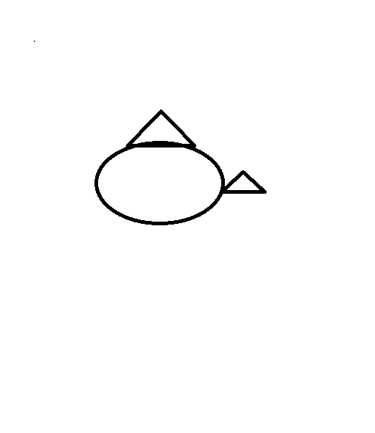

1. *Fish.PNG different Image correspond to original image Fig.2 Lamp.PNG.*

This is the Binarized form of different Image (*Fig.30 Fish.PNG*).After Binarization, it is used for prediction of Active column of Trained Image and Untrained Image.

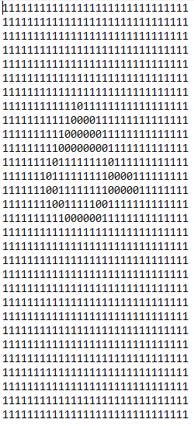

1. *Binarized image of different image (Fig.28 Fish.PNG).*

### Global Untrained:

The Graph shows the number of Active columns of different Untrained Image (*Fig.30 Fish.PNG*).This is the Graph showing the Active columns of Global untrained Different Image (*Fig.31 Fish.PNG)* which is taken as Different form of Image corresponding to Original Image *Fig.2 lamp.PNG.* The seen blue colored lines are representing Active columns of *Fig.30 Fish.PNG.* The total number of Active columns of untrained shifted image is 231 and the Hamming distance between untrained Image (*Fig.2 Lamp.PNG*) and prediction of same Image with Rotation (*Fig.21 LampRotate.PNG*) is 31. In Graph the vertical columns represents values (1 if the index of output column is Active and 0 if the index of output column is inactive). Moreover, the Horizontal axis shows the index of output column. As we can see in the Graph.

1. *Active column produced by Global Untrained spatial pooler for the different image fig.30.*

The Graph showing change in Active Columns between Global Untrained Original Image (*Fig.4)* and Different image (*Fig.32*).

1. *Active Columns, which are not common between Original Image and Different image produced by Global, untrained Spatial Pooler.*

Above Graph shows the difference between the active columns of Original Image and Different image produced by Global Untrained Spatial Pooler. The indexes at which these changes occur are shown as value 1. The total number of these indexes is 22. Also, the hamming distance in this case is 22, which denotes these indexes. Therefore, by the help of this graph we can compare the stability of image. If the density of these lines are less, then the image is stable as there are less changes or less hamming distance and if the density of these lines are more, then the image is less stable as there are more Changes or more hamming distance. Thus, by comparing the density of this graph, we can tell the stability.

### Global Trained:

The Graph shows the number of Active columns of different Trained Image (*Fig.30 Fish.PNG*).This is the Graph showing the Active columns of Global Trained Different Image (*Fig.34 Fish.PNG)* which is taken as Different form of Image corresponding to Original Image *Fig.2 lamp.PNG.* The blue colored lines are representing Active columns of *Fig.30 Fish.PNG.* The total number of Active columns of untrained shifted image is 72.

1. *Active column produced by Global Trained spatial pooler.*

### Local Untrained:

This is the Graph conclude the Active columns of Local untrained Image (*Fig.30 Fish.PNG).* The blue colored seen lines are representing Active columns of *Fig.35 Fish.PNG.* The total number of Active columns of prediction of Local untrained image is 214. And the Hamming Distance between untrained Image (*Fig.2 Lamp.PNG*).Where in the Graph vertical columns represents values (1 if the index of output column is Active and 0 if the index of output column is inactive). Similarly, the Horizontal axis shows the index of output column.

1. *Active column produced by Local Untrained spatial pooler.*

Change Graph of Active Columns between Local Untrained Original Image (*Fig.6)* and different image (*fig.35)*.

1. *Active Columns, which are not common between Original Image and Different image produced by Local Untrained Spatial Pooler.*

Above Graph shows the difference between the active columns of Original Image and Different image produced by Local Untrained Spatial Pooler. The indexes at which these changes occur are shown as value 1. The total number of these indexes is 72. Also, the hamming distance in this case is 72, which denotes these indexes. Therefore, by the help of this graph we can compare the stability of image. If the density of these lines are less, then the image is stable as there are less changes or less hamming distance and if the density of these lines are more, then the image is less stable as there are more Changes or more hamming distance. Thus, by comparing the density of this graph, we can tell the stability.

### Local Trained:

The below given Graph shows the Active Columns of Local Trained Image(*Fig.30 Fish.PNG*).This Graph represents Active columns produced by Local Trained image of *Fig.37 Fish..PNG.* Where vertical columns represents values (1 if the index of output column is Active and 0 if the index of output column is inactive). Similarly, the Horizontal axis shows the index of output column. . Moreover, the total number of Active columns is 228 and Hamming Distance is 22 for trained image *Fig.30 Fish.PNG* in local trained spatial pooler.

1. *Active column produced by Local Trained spatial pooler.*

Change Graph of Active Columns between Local Trained Original Image *(Fig.7)* and Different image *(Fig.37)*.

1. *Active Columns, which are not common between Original Image and Rotated image produced by Local, Trained Spatial Pooler.*

Above Graph shows the difference between the active columns of Original Image and Different image produced by Local Trained Spatial Pooler. The indexes at which these changes occur are shown as value 1. The total number of these indexes is 22. Also, the hamming distance in this case is 22, which denotes these indexes. Therefore, by the help of this graph we can compare the stability of image. If the density of these lines are less, then the image is stable as there are less changes or less hamming distance and if the density of these lines are more, then the image is less stable as there are more Changes or more hamming distance. Thus, by comparing the density of this graph, we can tell the stability. From Graph fig.36 and fig.38 we can say that trained image has less changed active columns than untrained image. Therefore, trained spatial pooler is more stable than untrained.

Output Overlap Table:

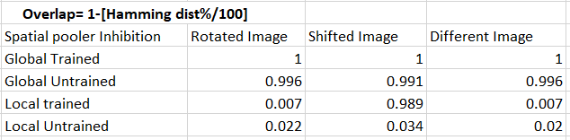

1. *Hamming Distance in percentage for several position with both Trained and Untrained Spatial Pooler.*

## Noise

### 0% Noise:

Active Columns of Prediction of Trained Images with Noise of 0% for *Fig.2 Lamp.PNG.*

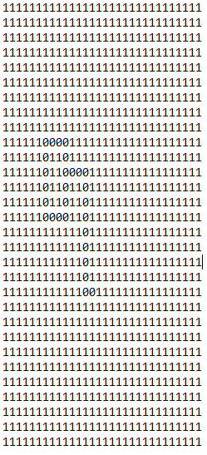

1. *Lamp.PNG Binarized image of original image (Fig.2 Lamp.PNG) with 0% Noise.*

### 1% Noise:

Binarized image of fig.2 with error 1% in figure 2 some active columns are changed in comparison to fig3 so, the Hamming distance is 66 and Hamming distance in percentage as 0.45% between trained image and prediction of same image with 90° rotation.

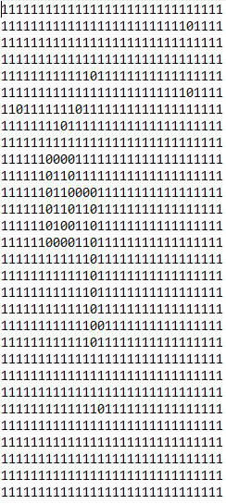

1. *Lamp­­ Binarized image with Adding 1% of noise.*

### 5% Noise:

Binarized image of *Fig.2 Lamp.PNG* with noise 5%, as we can see in this Binarized image with adding 5 percent of noise. Which is produced the hamming distance 114 between trained image and prediction of same image with Noise of 5 percent. In addition, given Hamming distance in noise as 1%.However Active columns are flipped densely but also image is stable and recognizable.

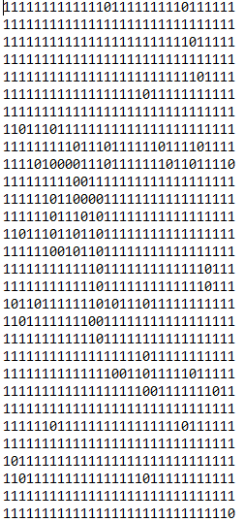

1. *Lamp.PNG Binarized image of Original Image adding 5% of noise.*

### 20% Noise:

This image is Binarized adding of with 20% of noise, which is, produced 159 hamming distance, which means active columns has bigger difference so the hamming distance in percentage become as 1.1%, which is giving as stabilized image.

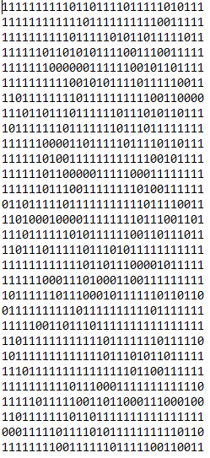

1. *Lamp.PNG Binarized image With 20% noise.*

### Hamming distance and Noise Graph:

#### Global Untrained:

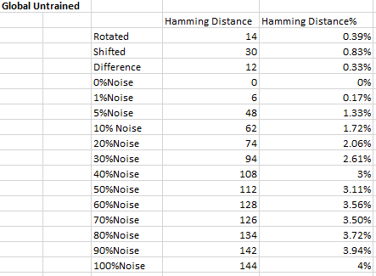

1. *Hamming distance for each percentage of noise added in Global Untrained Spatial Pooler.*

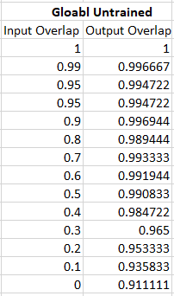

1. *Input and Output Overlap table For Global Untrained spatial pooler Image.*

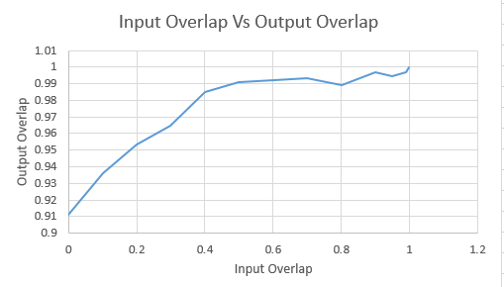

1. *Input Vs Output Overlap Graph for Global Untrained spatial pooler.*

This is the input vs output Overlap table for Global Untrained Spatial Pooler from which graph fig. 2.9 created.

Calculation:

Input Overlap = [1-(noise%/100)]

Output Overlap= [1-(Hamming distance%/100)]

This is the output overlap versus input overlap graph of image lamp.png. Input overlap is overlap of trained original input image after Binarization and same input image after Binarization with different levels of noise. Output overlap is overlap of output column of trained original input image after Binarization and output column of same input image after Binarization with different levels of noise. Here, we can observe the steepness or slope to determine its noise robustness. As we can see in the Graph, it shows stability on noise because Input Overlap decreases from right to left with increasing noise and output overlap is constant. If the curve is less steep for a noise range or the change in output overlap is not much with respect to input overlap, then it is more stable and if it is steeper for a noise range or the change in output overlap is more with respect to input overlap, and then it is less stable.

#### Global Trained:

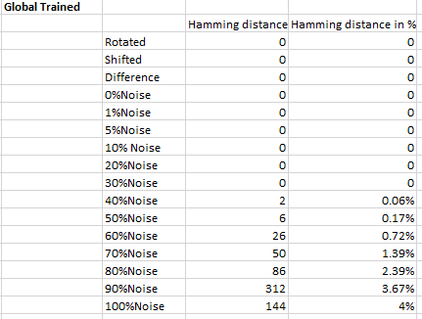

1. *Hamming distance for each percentage of noise added in Global Trained Spatial Pooler.*

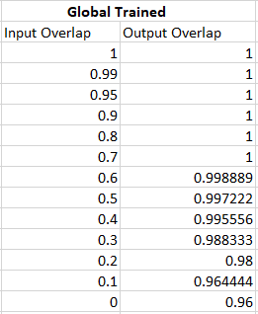

1. *Input Vs Output Overlap Graph for Global Trained spatial pooler.*

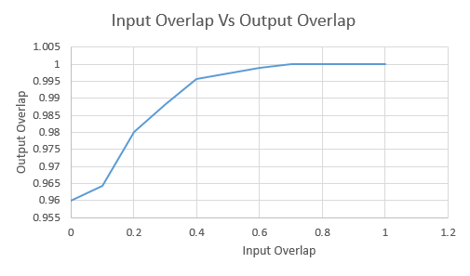

1. *Input Vs Output Overlap Graph for Global Trained spatial pooler.*

This is the input vs output Overlap table for Global Trained Spatial Pooler from which graph fig. 47 created.

Calculation:

Input Overlap = [1-(noise%/100)]

Output Overlap= [1-(Hamming distance%/100)]

As seen in graph, it is showing less stability on noise than Fig.45.Since, input Overlap Decrease slightly from right to left with Increasing Noise.

This is the output overlap versus input overlap graph of image lamp.png. Input overlap is overlap of trained original input image after Binarization and same input image after Binarization with different levels of noise. Output overlap is overlap of output column of trained original input image after Binarization and output column of same input image after Binarization with different levels of noise. Here, we can observe the steepness or slope to determine its noise robustness. If the curve is less steep for a noise range or the change in output overlap is not much with respect to input overlap, then it is more stable and if it is steeper for a noise range or the change in output overlap is more with respect to input overlap, and then it is less stable.

#### Local Untrained:

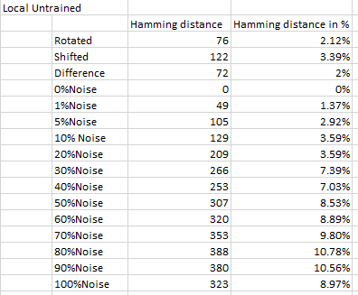

1. *Input and Output Overlap table For Local Untrained spatial pooler Image.*

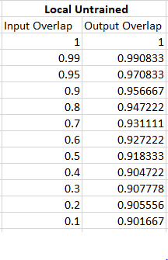

1. *Input Vs Output Overlap Graph for Local Untrained spatial pooler.*

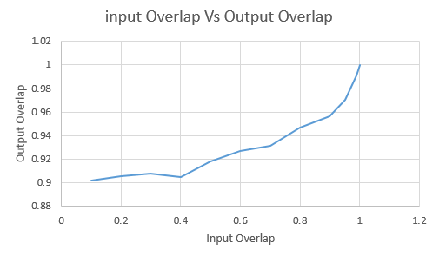

1. *Input Vs Output Overlap Graph for Local Untrained spatial pooler.*

This is the input vs output Overlap table for Local Untrained Spatial Pooler from which graph fig. 50 created.

Calculation:

Input Overlap = [1-(noise%/100)]

Output Overlap= [1-(Hamming distance%/100)]

The Graph obtained by local Untrained seems not stable on noise because the output Overlap is decreasing from right to right with increasing noise this is the output overlap versus input overlap graph of image bat1.png. Input overlap is overlap of trained original input image after Binarization and same input image after Binarization with different levels of noise. Output overlap is overlap of output column of trained original input image after Binarization and output column of same input image after Binarization with different levels of noise. Here, we can observe the steepness or slope to determine its noise robustness. If the curve is less steep for a noise range or the change in output overlap is not much with respect to input overlap, then it is more stable and if it is steeper for a noise range or the change in output overlap is more with respect to input overlap, then it is less stable.

#### Local Trained:

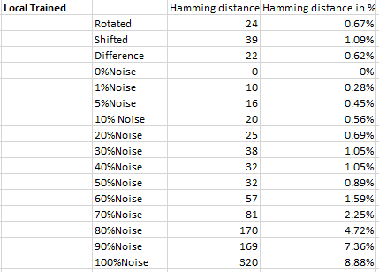

1. *Input and Output Overlap table for Local Trained spatial pooler Image.*

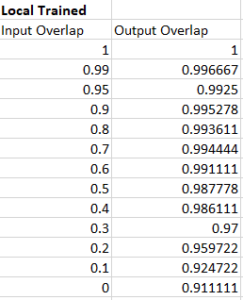

1. *Input Vs Output Overlap Graph for Local Trained spatial pooler.*

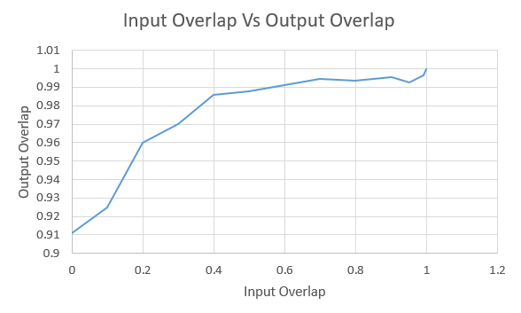

1. *Input Vs Output Overlap Graph for Local Trained spatial pooler.*

Calculation:

Input Overlap = [1-(noise%/100)]

Output Overlap= [1-(Hamming distance%/100)]

This graph shows good stability over noise with increasing output overlap from left to right consistently with increasing noise factor. Therefore this is stable than untrained inhibition.

This is the output overlap versus input overlap graph of image bat1.png. Input overlap is overlap of trained original input image after Binarization and same input image after Binarization with different levels of noise. Output overlap is overlap of output column of trained original input image after Binarization and output column of same input image after Binarization with different levels of noise. Here, we can observe the steepness or slope to determine its noise robustness. If the curve is less steep for a noise range or the change in output overlap is not much with respect to input overlap, then it is more stable and if it is steeper for a noise range or the change in output overlap is more with respect to input overlap, and then it is less stable.

### Inhibition Comparison Graph:

1. *Input Vs Output Overlap Graph for Trained and Untrained spatial pooler.*

This is the output overlap versus input overlap graph for all trained and untrained images in different Inhibition. We can see in the graph from Global trained Inhibition is more stable on noise because the output overlap is constant with increasing noise since it is showing constant with noise adding. Similarly, local trained is more stable than untrained images on noise. As we can see n graph the local untrained is not stable with noise since its decreasing from right to left with decreasing noise level. Other two Local Trained and Untrained. Moreover, Global and Local Untrained is more stable than local trained since the stability robustness is not good with untrained image. Since, we can observe the steepness or slope to determine its noise robustness. If the curve is less steep for a noise range or the change in output overlap is not much with respect to input overlap, then it is more stable and if it is steeper for a noise range or the change in output overlap is more with respect to input overlap, and then it is less stable. Local Untrained has lowest stable and global trained has highest stability over noise.

# discussion and conclusion

The goal of this project is to check stability of similar images over noise and to find out Active columns and hamming distance from trained and untrained image data via noise graph and table. We can conclude that images stability are depending up on the noise added due to which Hamming distance percentage produced. Untrained images are less stable over noise than trained images. Below 1%, Hamming distance obtained with addition of 1 to 5% of noise. Moreover, Images stability was good up to with 20% errors.

However, adding noise more than 10% i.e. 20% up to 100%, Active columns has been changed with big difference and hamming distance percentage obtained as equal or above than 1% which did not give stable images . The above given table and Graph for the trained image of stability’s robustness. Calculated Image are obtained by using local and Globlal inhibitaion and as we can see the robustness in stability of image is seen in graph, the steepness or slope to determine its noise robustness. If the curve is less steep for a noise range or the change in output overlap is not much with respect to input overlap, then it is more stable and if it is steeper for a noise range or the change in output overlap is more with respect to input overlap, and then it is less stable.

## Advantages

We can check the stability of similar images also for forensic use.

In the old days, Banalization was important for sending faxes.

These days it is still important for things like digitalizing text or segmentation.

## Disadvantages

Consume time for high-resolution images.

# REFERENCES

[1] Jeff Hawkins, "Hierarchical temporal memory (HTM)," Numenta,

Huntington, New York, United States, 2004.

[2] <https://github.com/UniversityOfAppliedSciencesFrankfurt/se-dystsys->

(open source) 2018-2019-softwareengineering

[3] Yuwei Cui , Subutai Hamad, Jeff hawkins Inc,redwood Marcin ,City Ca, United States

[4] Pietron,Kazimier Wia, Poland of science and technology al.Mickiewica